**PROJECT REPORT**

Vipassanā – Insight Awareness (VIA)

System and Website

**Supervisors**

Mona Wendel Andersen

Michael Viuff





**Students**

Andrei Cioanca – 266105

Stefan Harabagiu – 266116

Nikita Roshkov – 266900

Dawei Li – 269053

**Characters** – 1233312

**ICT Engineering** 1st Semester

11/12/2017

**Students**



Andrei Cioanca – 266105

I hereby declare that my project group and I prepared this project report and that all sources of information have been duly acknowledged.



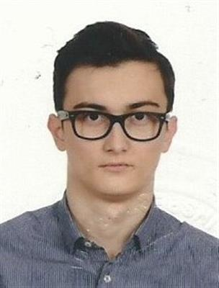

Dawei Li – 269053

I hereby declare that my project group and I prepared this project report and that all sources of information have been duly acknowledged.



Nikita Roshkov – 266900

I hereby declare that my project group and I prepared this project report and that all sources of information have been duly acknowledged.



Stefan Harabagiu – 266116

I hereby declare that my project group and I prepared this project report and that all sources of information have been duly acknowledged.



# Acknowledgements

# The team wishes to formally acknowledge VIA University College’s active implication in the evolution and completion of this project work. All documents contained or referred to from this project are based on VIA University College’s templates and designs. All information present in this document, while original in itself, could not have been made possible without VIA’s designs and templates.

# Version history

# Abstract

# Table of Figures

# Table of Contents

# Introduction

Vipassanā - Insight Awareness (VIA) is a center for spiritual events with a strong base in Buddhist practices of meditation and spirituality. Its’ purpose is to offer people a safe heaven where they can hold and take part in different spiritual events of many creeds (VIA Interview). Today’s events at VIA, amongst the spiritual kind, also include practices not directly linked to any religious agendas such as dream interpretation, healing, astrology, reincarnation or karma. The organization also holds a large number of lectures, workshops, seminars and through partnerships with third party organizations also trips (Example of an Event).

Thus said, the company lacks any kind of system that holds or retains the information they need in order to run and organize all the events properly. Vital information such as start times, dates, attendees, lecturers or sponsor names get lost with the day-to-day activities and practices the organization delves in. The employees usually have a hard time remembering certain details about the lectures or workshops such as specific food requirements or simple names or subjects the lectures might contain.

VIA also has issues with creating a stable online presence. A high percentage of the target audience for these kind of spiritual events remains untapped due to VIA having a largely unknown presence to its local community both online and in real life.

They currently have no way of advertising themselves online or retaining information about their current members, lecturers or potential sponsors.

A system tailored specifically to VIA’s requirements even if at best would only faintly resemble a true database, would contribute immensely to the organization’s day-to-day activities. Having such a system at their disposal would not only give the employees a much-needed break when it comes to remembering certain details but it would also give VIA the opportunity to focus their efforts on improving itself as a company and give a greater level of satisfaction to their customers.

Our objective as developers is to create this system from scratch and tailor it to the organization’s specific needs. We aim to implement the baseline requirements provided by the company’s leadership which include basic information storage and readability, while also embellishing the system with much needed quality of life changes such as the ability to store starting dates for events, duration, what lecturers will take part in it and so on and so forth.

Our primary objective is to provide VIA with a stable and robust system that not only would fulfill their requirements but also improve on them significantly with what their employees need in order to facilitate day-to-day activities.

This task does come with its’ fair share of technical difficulties that would need to be tackled in a professional manner by our developer team. Obstacles such as file usage in secondary storage and providing employees with a readable and easily understandable and distinguishable GUI are not only tackled during development but also detailed in this project report. Creating a system from scratch and delivering it to the stakeholder in itself is a technical difficulty and every substantial development in the program is documented and thoroughly tested.

As for project delimitations, as junior developers we will not handle any kind of linkage between the customer’s ordered website and the system itself even though either of their developments have taken inspiration from one another. While we retain the responsibility of having a simple, easy to understand and most importantly functional UI, we will not make a priority of having a complex and detailed one seeing as the endeavor would largely fall short of the focus of this project. Any guidance towards the usage of the system will be done remotely through our provided user guide, the team won’t divert resources to teaching the end-user how to operate the system manually. On this note, the actual deployment of the system will also not be handled by our junior developer team.

Even though legal issues have a fair positive percentage in our development cycle of the website and system, we will not pursue any endeavor of tackling them whatsoever.

Expectancy of resolution on part of the developer team on these issues is understandable but what is more important is the fact that they currently fall out of the primary focus of this project and that is handling the complete development of a single user system and website alongside any documentation it requires.

The development itself started with a list of functional and non-functional requirements, the baseline of our system and a blueprint to what the system should be able to do and potentially not do according to the stakeholder’s needs. They are both detailed in the next section of this report.

# Functional and non-functional requirements

The requirements overall represent what our employer Vipassanā - Insight Awareness would like the system to do overall. Due to VIA’s untrained status in software development we have taken a few liberties with some specific requirements, adding quite a handful to ease development and overall build a more stable and robust system.

## Functional requirements

1. The user should be able to create a new event.
2. The events can be of four different types (lectures, seminars, workshops and trips).
3. The system should store the following information about the lectures: a title, start date, start time, duration, lecturer, 1 subject, sponsor name, price, finalized or not, total number of tickets, discount.
4. The system should store the following information about the lectures: a title, start date, start time, duration, lecturer, 1 subject, sponsor name, price, finalized or not, total number of tickets, discount.
5. The system should store the following information about the workshops: a title, start date, start time, duration, lecturers, food included (vegan or not), price, finalized or not, total number of tickets, discount.
6. The system should store the following information about the trips: a title, start date, start time, duration, locations, price, finalized or not, total number of tickets, discount.
7. The user should be able to search events by: finalized or not, start date, subject, price, lecturers, sponsors.
8. The user should be able to modify every aspect of an event.
9. The user should be able to store members’ information.
10. Members are defined by name, email, address, phone, payment year, date of registration, newsletter subscription, attended events.
11. The user should be able to search members by name, payment year, date of registration, attended events.
12. The user should be able to update the information of each member.
13. The user should be able to store lecturers’ information.
14. Lecturers are defined by name, email, phone, sponsor or not, subject.
15. The user should be able to search lecturers by name, subject, email, phone, sponsor or not.
16. The user should be able to update the information of each lecturer.

## Non-functional requirements

1. The system has to be implemented in Java.
2. The system has to be compatible with Microsoft Windows 7,8,10.
3. The system needs to be able to run with no complications for long periods of time.
4. The system should use files for secondary storage only.

We feel these requirements are suitable for Vipassanā, making the system complex in nature while retaining a robust and clean structure with good maintainability. These requirements are better explained and detailed in the next section of the project report, the analysis, where we present the system and website itself through diagrams that would aid the uninitiated in understanding our design.

Due to the fact that the website is not the central focus of this project, we’ve decided to restrict its presence and not present it as extensively as the system.

# Website Analysis

The sketch below has been provided by VIA to serve as an example of what they would like their website to look like.

VIA Website

Diagram1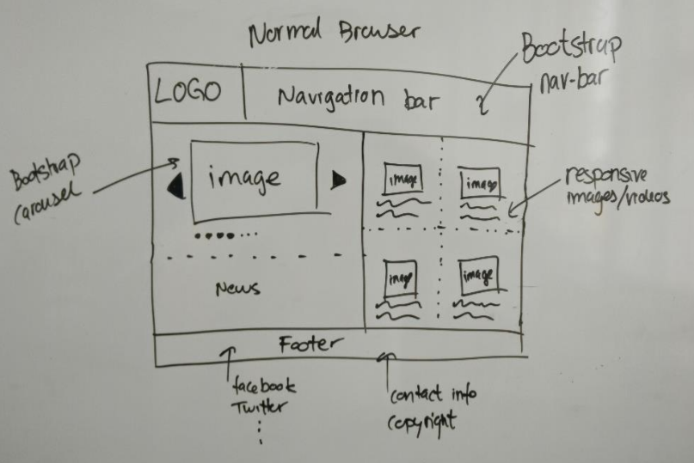

As you can see from the sketch we have a very solid foundation of what the website would look like. Apart from a few details, such as the size of different elements within the website or having more pages than usual to aid with the structuring of information, the final website faithfully kept the initial design.

VIA also required that the website be responsive meaning that all the different elements of the website will not become unusable or unreadable upon modifying the window size or switching the device the website is viewed from. In this regard they have also provided another sketch in which they detail how they would like the website to be viewed on a mobile phone.

VIA Website Diagram 2

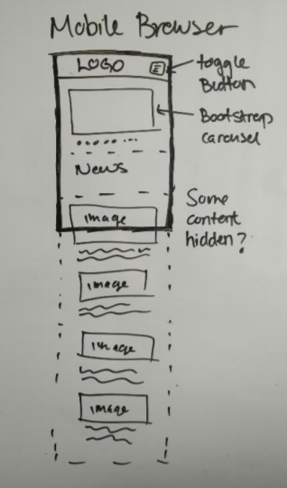

Pretty straightforward in terms of design, nothing special apart from a few “carousel” type elements.

Having both of these initial sketches helped our team tremendously in developing the website. Having been spared the process of coming up with interesting designs and present them to our employer before any actual development was done, we could focus on implementing the actual website and working on providing VIA with the online identity it lacked for such a long time.

To do all this, we came up with a few interesting design choices that are detailed in the following section.

# Website Design

When designing the website we already knew that responsiveness on different devices and window sizes would play a key part in the product’s overall presentation. With this information in mind we decided that implementing it with bootstrap would be the best design choice.

As you can see from the picture below, our design does not differ that much from what was provided by VIA.

Website 1

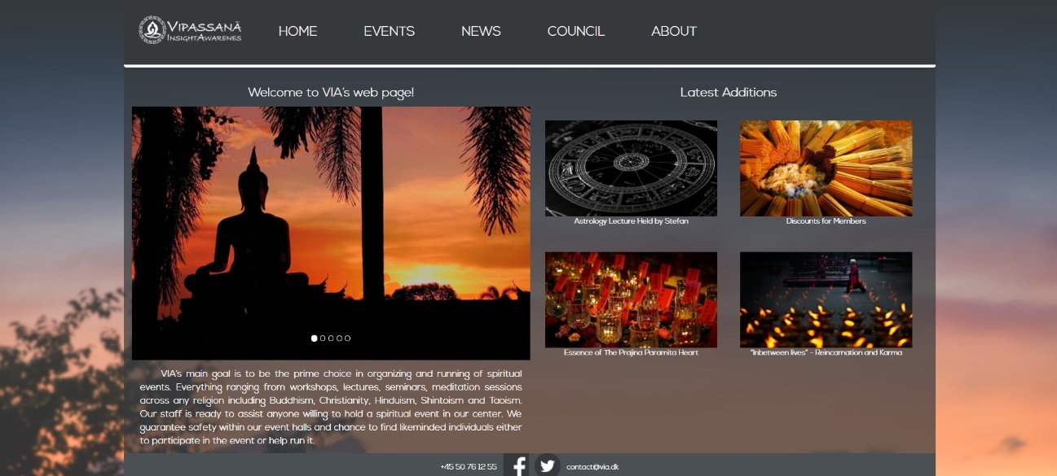

We have maintained the look of the navigation bar, with its logo to the left and buttons to the right, we have also maintained the structure of the main content, having the moving carousel element to the left side of the screen and the “Latest Additions” section to the right.

The aesthetics of the page are what we ourselves came up with since the stakeholder gave us freedom over the looks. We gave the website a neutral look, with a black and white colour scheme with a grey sliver underneath, overlooking a beautifully contrasted background image.

As for the other pages, we’ve applied the same design principles, keeping VIA’s requirements in focus at all times.

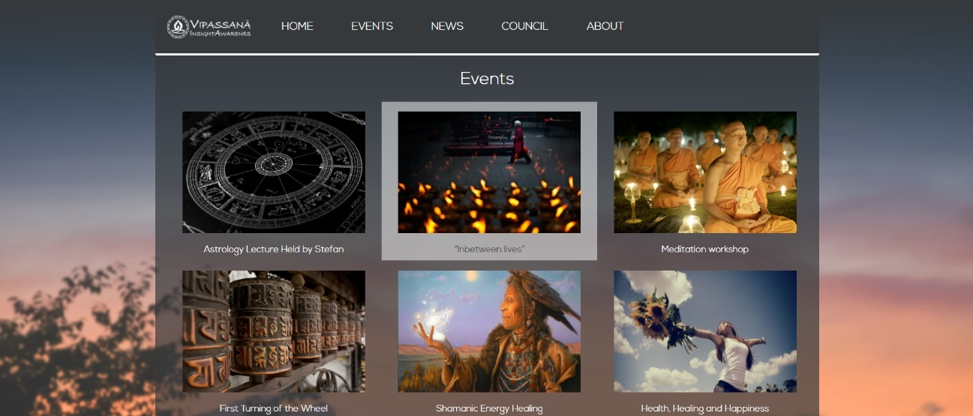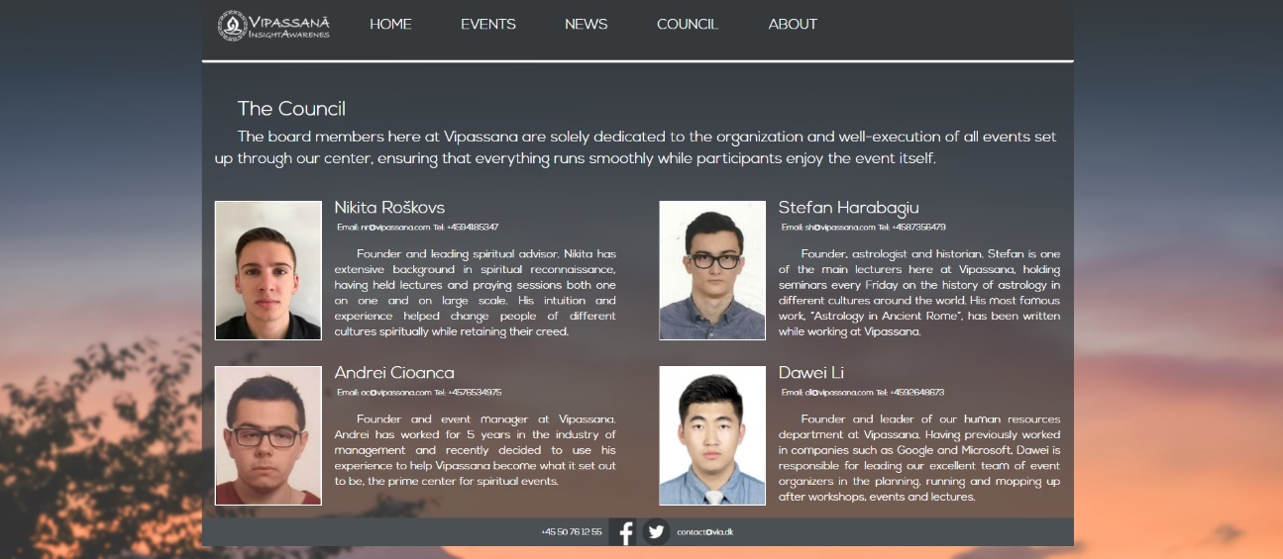

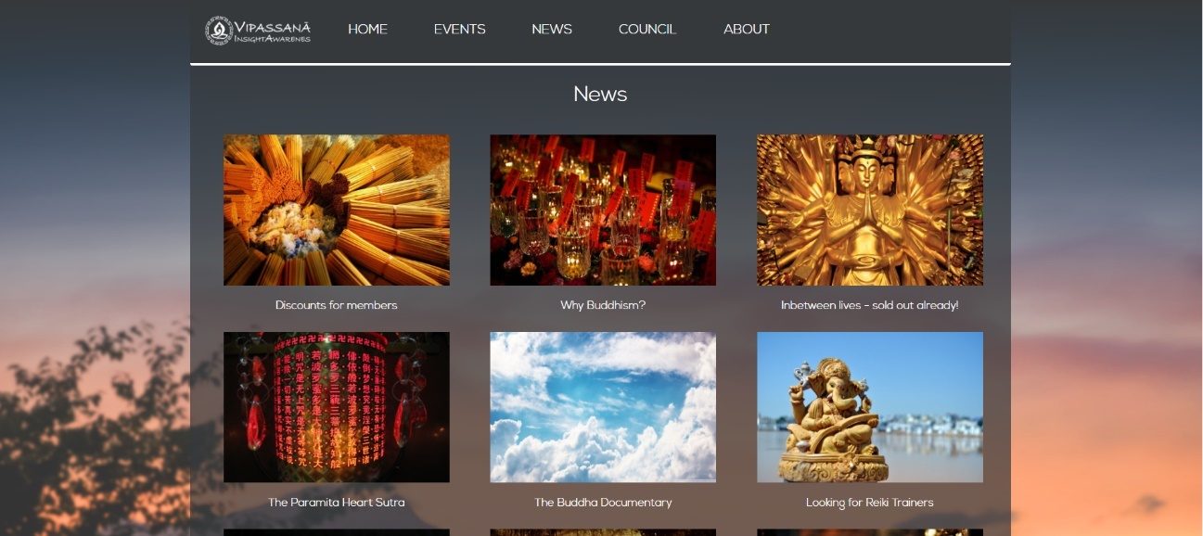

Due to the fact that the website isn’t the main focus of the project and that we have already demonstrated its’ abilities to the stakeholders, we have purposefully omitted the implementation part of this report.

# Analysis

The diagram below shows a basic representation of the system and how it overall functions.

VIA System Basic Functionality

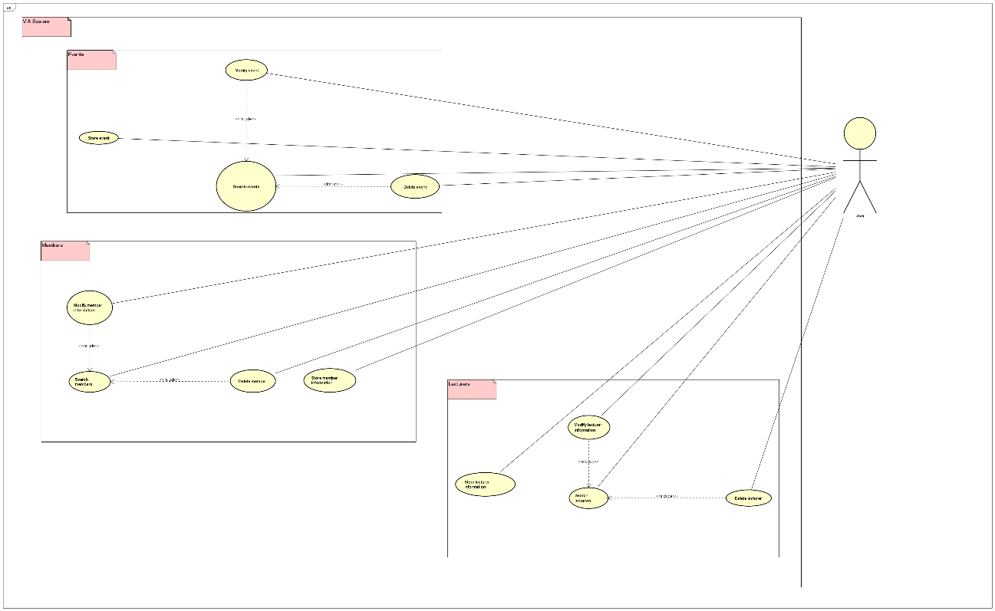

As it is seen in the diagram, the user is able to access three distinct parts of the system, the member list, the lecturers list and the event list. Each part of the system will allow him to add, remove, edit and search by a parameter for a member, an event or a lecturer. The diagram shows all of the basic requirements stated by the stakeholder.

The team has also provided a diagram description of the same process.

Activity Diagram for Storing an Event

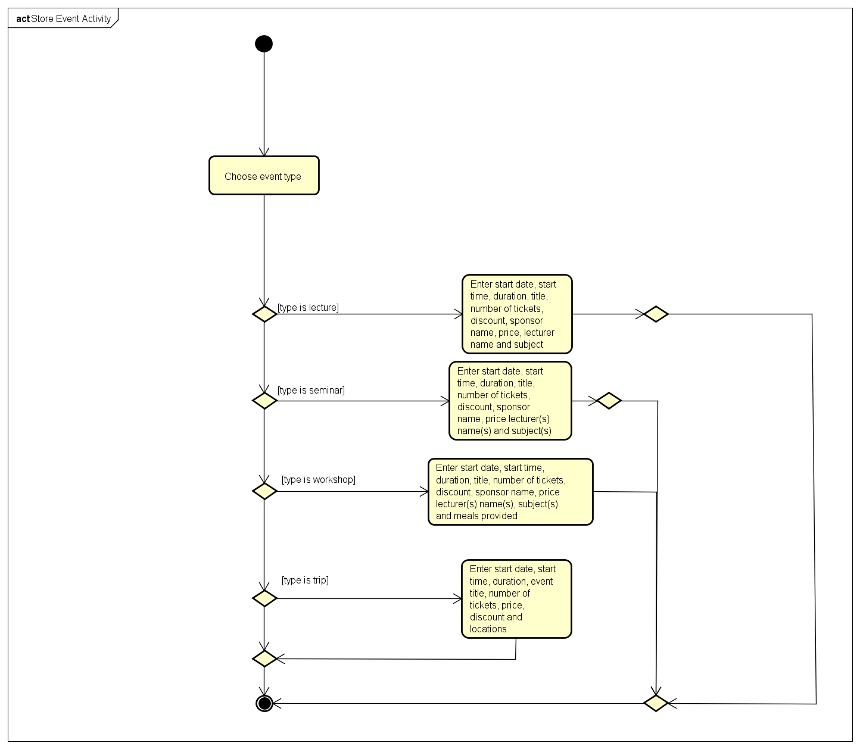

Use-Case Description for Storing an Event

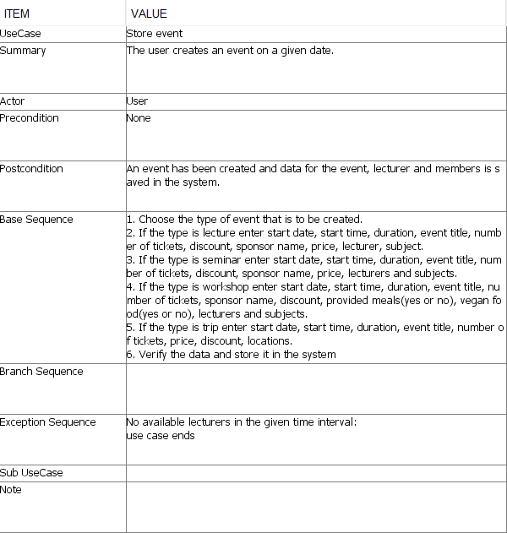

Following the diagram from its entry point we can begin to understand how the system stores its events. The only complexity that may arise from the diagram would be the branching of flows depending on whether the event is a lecture, a seminar, a workshop or a trip. This representation should offer a solid understanding of how the most critical part of our system functions, the storing of events.

For comparison in terms of similarity and complexity we have also provided a diagram for adding a member in the system.

Activity Diagram for Storing a Member

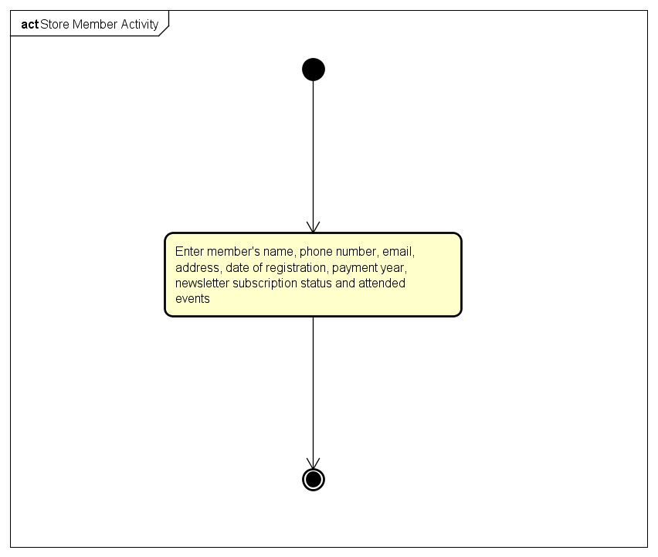

Both processes are strikingly similar only diverging in terms of programming logic approach and order. There is no denying that adding a member is made very simple by the fact that there are only one kind of members and not many different ones as is the case for events.

Below is an updated description of the same process of adding a member in the system that should paint a clearer picture of how the process works.

Add Member UseCase Description

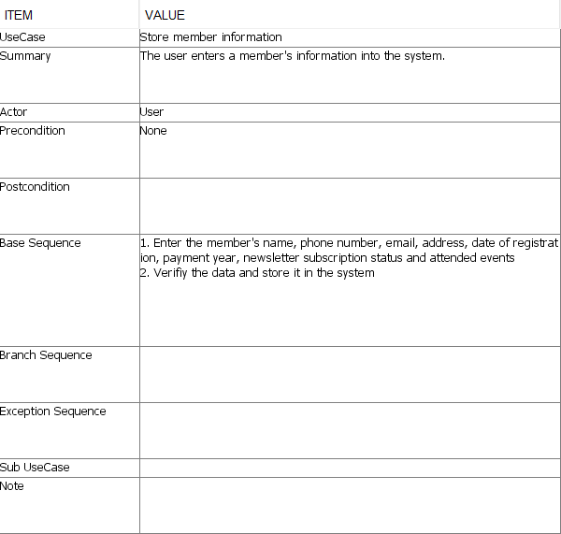

The base sequence is executed in order, from 1 to 2, when the user wishes to add a new member. This is similar to how all the other parts function such as removing a member, adding an event, etc.

Following our analysis of the system and our initial diagrams we decided upon the following design choices.

# Design

We knew from the start that the system would make use of a GUI but seeing as this was the first time the team dealt with anything remotely resembling a user interface we decided to start off by making the whole system work on its own without any aid from a GUI.

Naturally we began expanding on the basic functionality diagram and we came up with a complex UML diagram that served as the basis of our implementation.

//UML diagram

As you can see from the UML the system has 15 separate classes each with its own piece of functionality.

Naturally the system will be accompanied by a GUI as well. A very basic model was adopted with no added complexity or any other embellishments in order to keep it as “clean as possible”. The diagram below shows the basic functionality of the GUI.

GUI Basic Functionality

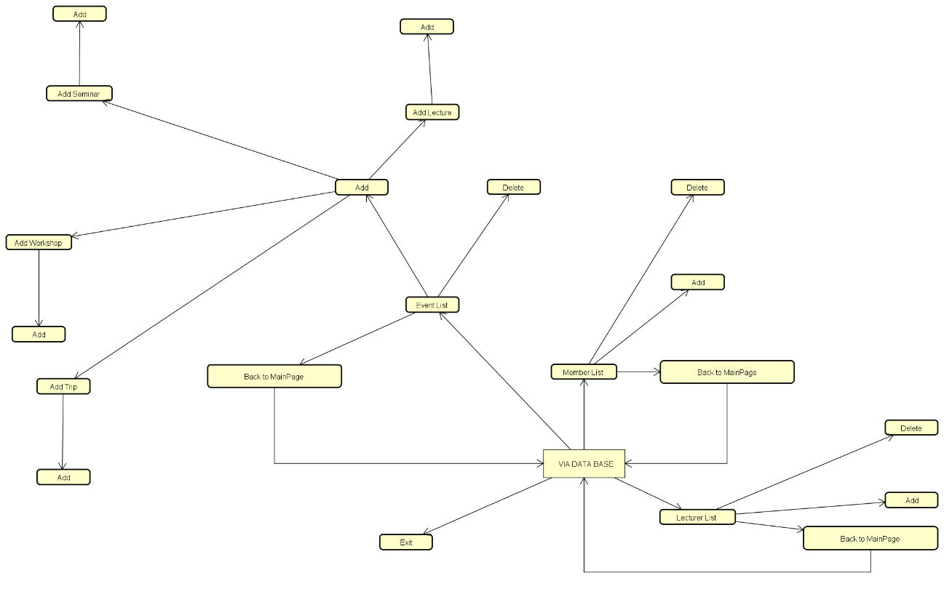

As you can see the boxes can be thought of as “buttons” and the arrows connecting them between each other as “access points”. For example, you can access the LECTURER LIST part of the system through a button located in VIA SYSTEM.

In order to add a new MEMBER in the system, the user would need to access the MEMBER LIST from VIA SYSTEM and then click on ADD. Every aspect of the back-end functionality of the GUI and the system itself will be explained in-depth in the design part of the document. Hopefully, through these simple diagrams and explanations you now have a basic understanding of how the system works and how the GUI is connected to it.

# System Implementation

The system developed by our group consists of three different lists of objects that represent the events hosted by the company, the lecturers hired by them and the members of their organization.

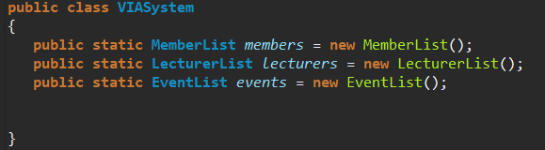When the user runs the application, the system will check to see if there are any files that store previous data and will read them in order to initialize the lists. The system will instantiate the required objects and use a FileController class to access and call the *readFile* methods for each *member, lecturer* or *event* object.

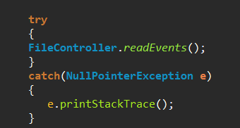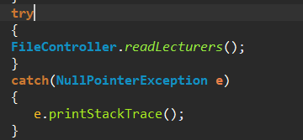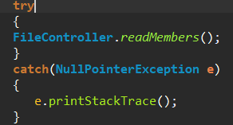

As stated before, the methods called on the FileController class instantiates as many objects as needed and then calls the required method for that object:

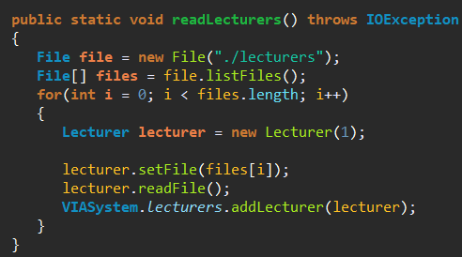

Then the user will be presented with three different choices: Events, Lecturers or Members. If he clicks on any of those buttons he will be taken to another frame of the UI that will display all the objects as a list. We used a *jList* to achieve this in which we stored objects and then used a custom made ListCellRenderer class in order to control what information will be displayed.

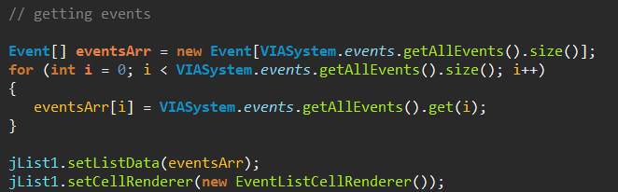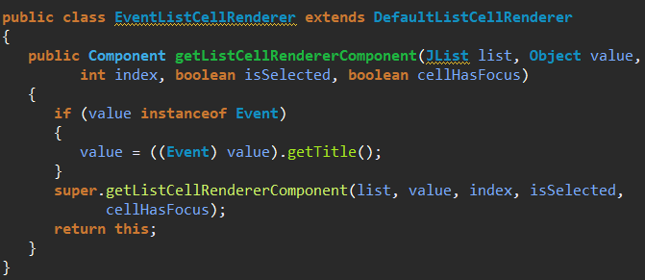

In order to create another event, the user only needs to click on the add button which will take him to a new frame in which he will have to select what type of event he wishes to create (lecture, seminar, workshop or trip). After clicking on one of the four buttons a new frame will open in which he will enter the data required to create that type of event (the *Lecture, Seminar, Workshop* and *Trip* classes are all children of the *Event* class). After finishing writing the date the system will instantiate a new object and add it to the *events* list. When the user chooses to close the system the FileController class will be used again to write everything that has been created up until now to files.

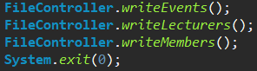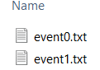

The system also allows the user to search the list by several parameters. Depending on what parameter the user chose the system uses specific code to search the list and display each element.

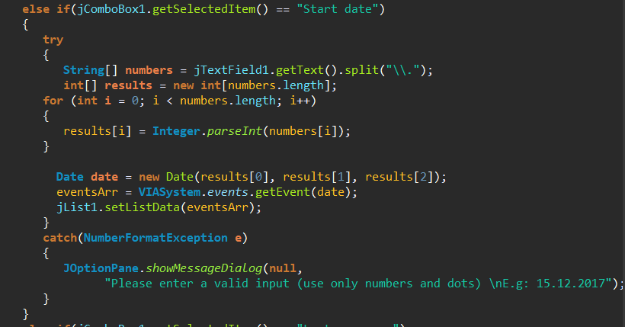

Furthermore, the system generates a unique ID for every event, lecturer or member and uses them in the naming of their files and for easily distinguishing each object from another.

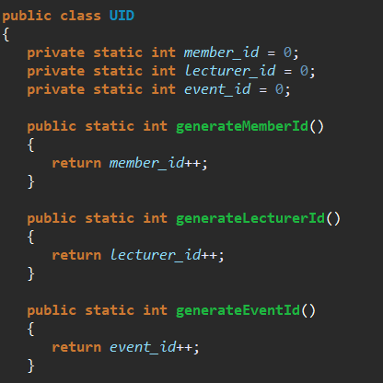

An example for the usage of these IDs is a *member’s* list of attended events. Instead of creating a list of *event* objects the system instead stores the ID of the event. When creating a member for example the user chooses which events the member attended and the *member* object is being attributed and ArrayList consisiting only of the ID of each event.

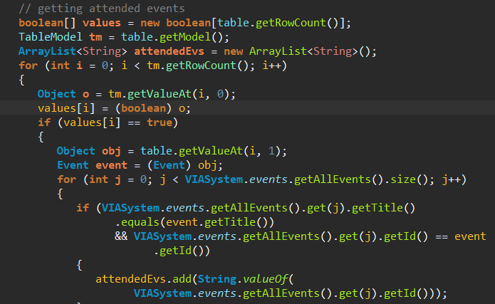

# Test

The system was tested according to the requirements that the group wrote in order to assure the system’s functionality. The GUI was tested as well to ensure that it follows what was specified in the Use Case Descriptions.

GUI

1. Store event
2. The user first chooses the type of event he wishes to add
3. The user enters the required data into the system
4. The system verifies the data and stores it

PASSED

1. Search events
2. The user enters a search parameter
3. The system checks and lists every event that meets the requirements
4. If there is no event with that requirement, the list displayed will be empty

PASSED

1. Modify event
2. The user selects the desired event
3. The user enters new data
4. The system verifies the data and stores it

PASSED

1. Delete event
2. The user selects the event that needs to be deleted
3. The system deletes the event

PASSED

1. Store member information
2. The user enters the required data into the system
3. The system verifies the data and stores it

PASSED

1. Search members
2. The user enters a search parameter
3. The system checks and lists every member that meets the requirements
4. If there is no member with that requirement, the list displayed will be empty

PASSED

1. Modify member information
2. The user selects the desired member
3. The user enters new data
4. The system verifies the data and stores it

PASSED

1. Delete member
2. The user selects the member whose information needs to be deleted
3. The system deletes the member’s information

PASSED

1. Store lecturer information
2. The user enters the required data into the system
3. The system verifies the data and stores it

PASSED

1. Search lecturers
2. The user enters a search parameter
3. The system checks and lists every lecturer that meets the requirements
4. If there is no lecturer with that requirement, the list displayed will be empty

PASSED

1. Modify lecturer information
2. The user selects the desired lecturer
3. The user enters new data
4. The system verifies the data and stores it

PASSED

1. Delete lecturer
2. The user selects the lecturer whose information needs to be deleted
3. The system deletes the lecturer’s information

PASSED

SYSTEM

1. The user can create a new event PASSED
2. Events can be of four different types PASSED
3. The system should store about lectures: a title, start date, start time, duration, lecturer, 1 subject, sponsor name, price, finalized or not, total number of tickets, discount PASSED
4. The system should store about seminars: a title, start date, start time, duration, lecturers, subjects, sponsor name, price, finalized or not, total number of tickets, discount PASSED
5. The system should store about workshops: a title, start date, start time, duration, lecturers, food included (vegan or not), price, finalized or not, total number of tickets, discount PASSED
6. The system should store about trips: a title, start date, start time, duration, locations, price, finalized or not, total number of tickets, discount PASSED
7. The user should be able to search events by: finalized or not, start date, subject, price,lecturers, sponsors PASSED
8. The user should be able to modify every aspect an event PASSED
9. The user can store a member’s information (name, email, address, phone, payment year, date of registration, newsletter subscription, attended events) PASSED
10. The user should be able to search members by name, payment year, date of registration, attended events PASSED
11. The user should be able to update the information of each member PASSED
12. The user can store a lecturer’s information (name, email, phone, sponsor or not, subject) PASSED
13. The user should be able to search lecturers by name, subject, email, phone, sponsor or not PASSED
14. The user should be able to update the information of each lecturer PASSED

Besides using the final version of the system to test its functionality there has been created a tester class in order to check for more specific errors.

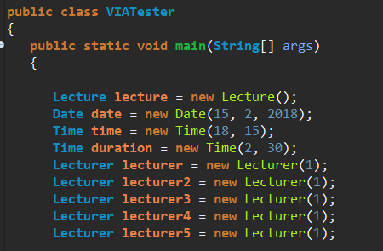 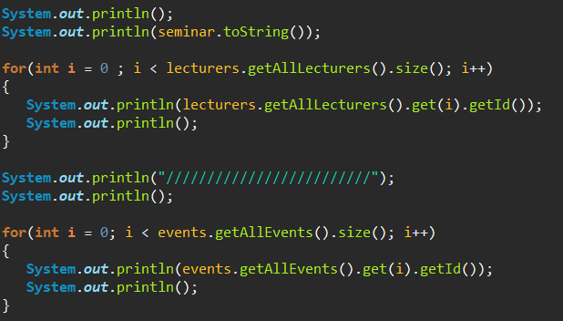

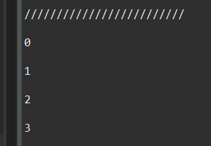 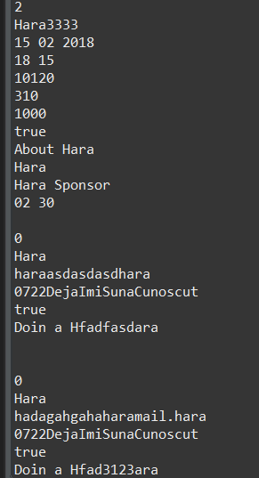

# Results and Discussion

# Conclusion

# Project Future

Our group is overall satisfied with the project implementation. From a technical viewpoint everything is done correctly and all the requirements have been met, however, there are a few more improvements we could make regarding the current version of the application. The user input validation could be improved to prevent incorrect data input and offer more stability to the system. Also we could create a utility controller class, however, it is not an essential function for our system to have beacause of it’s simplicity.

Apart from that, there are a lot more improvements that could be made in order to make the project ready for some kind of deployment stage. The first step would be connecting the application with the website. We could add a login system to our website, so that users can create accounts by themselves and it would be automatically created on the server without any administrator’s manual input. Furthermore we could supplement the website with more functionality for users such as ticket reservation, event marking, and a private message system.

As for the application itself, we could make a history list, so the administrator cansee all of the changes that were previously made. Moreover, an essential feature would be the administrator’s ability to restore recently deleted files, to achieve this we would use the simplest functions of hiding data for specific periods of time before deleting it completely, after the administrator actually calls the delete method.

# References

# List of Appendices